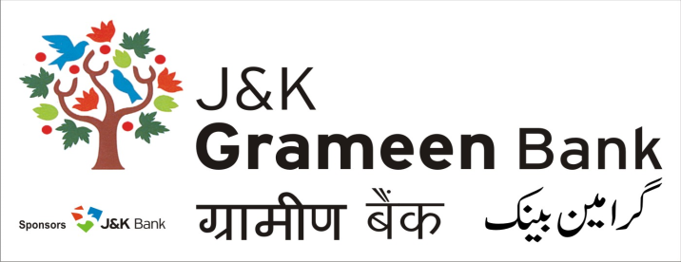
General Administrative Deptt. (GAD)
HEAD OFFICE
NARWAL, JAMMU
Mobile No.: 9797127377
E-mail: pdg.hoj@jkgb.in
Website: www.jkgb.in
-------------------------------------------------------------------------------------------------------------------------------
Ref. No: JKGB/GAD/19-5142 Dated: 15-01-2019

Notice inviting tenders for AMC of UPS in Jammu Region

For & on behalf of J&K Grameen Bank, sealed tenders are invited from interested parties having experience in the field for AMC of UPS installed at various branches/offices of the bank in Jammu region as per Terms and Conditions in Tender Document.

Interested parties can obtain the tender form along with other details during working hours from 17.01.2019 to 05.02.2019 from our Bank’s General Administrative Department (GAD) at Head office, Near fruit complex, Narwal, Jammu on cash payment of ₹ 500/- (Rupees Five Hundred only).

Tenders shall be received only in two separate covers. Cover I (technical Offer) containing non priced Prequalification Document, accepted Terms & Conditions, Technical Specifications accompanied with Earnest Money in the shape of a CDR of any bank for an amount of ₹ 25,000/- (Rupees Twenty Five Thousand only) pledged to General Manager, J&K Grameen Bank, Head Office Narwal, Jammu. Cover II (Commercial Offer) shall contain Price Bid only. Both the sealed covers should be enclosed in a single cover addressed to General Manager, J&K Grameen Bank, Head Office Narwal, Jammu and should be delivered in his office on or before 06.02.2019 upto 4.00 pm.

The tenders shall be opened on 07.02.2019 at 12 PM, in the presence of tenderers, who desire to be present at the time of opening of the tenders. The tenders shall be opened by the committee members, whose decision shall be final.

The Bank reserves the right to accept or reject any offer/all offers without assigning any reason thereof.

Sd/-
Chief Manager
General Administrative Deptt. (GAD)
J&K Grameen Bank

