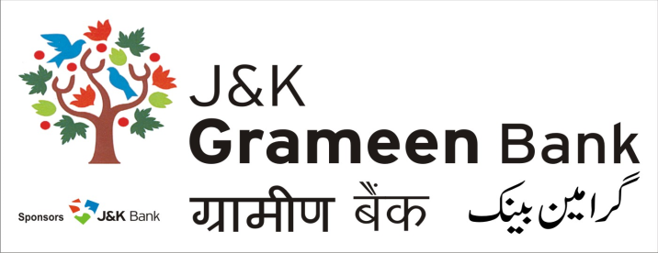
General Administrative Deptt. (GAD)
HEAD OFFICE
NARWAL, JAMMU
Mobile No.: 9797127377
E-mail: pdg.hoj@jkgb.in
Website: www.jkgb.in
-------------------------------------------------------------------------------------------------------------------------------
Notice for extension of Tender

For Providing and Fixing Flex Sign Board to various Branches of J&K Grameen Bank on need basis in Jammu Division - Extension

Please refer to the captioned tender floated for the above work by General Administrative Department, J&K Grameen Bank issued vide Ref No: JKGB/GAD/20/1575 Dated: 17.08.2020.

In this connection, it is to inform that last date has been extended as per below mentioned schedule:
Issue of tender: upto 19.09.2020.
Last date of submission: 19.09.2020 UPTO 2.00 PM.
Tender opening: 21.09.2020 AT 12 PM.

Sd/-

HOD,
General Administrative Deptt.
J&K Grameen Bank Dated: 04.09.2020

