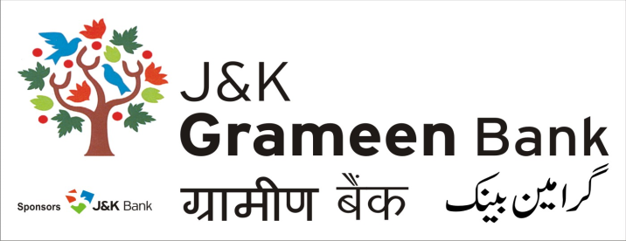
General Administrative Deptt. (GAD)
HEAD OFFICE
NARWAL, JAMMU
Mobile No.: 9797127377
E-mail: pdg.hoj@jkgb.in
Website: www.jkgb.in
……………………………………………………………………………………………………………
Ref.No: JKGB/GAD/18-7133 Date: 07.03.2018

Notice inviting tenders for Supply and installation of UPS batteries and/or Genset batteries in Jammu Region.

Sealed Quotations marked “ Quotations for supply and installation of UPS batteries and/or Genset batteries” are invited from the interested parties who have satisfactorily completed work during the last two financial year 2015-16 and 2016-17 in any Govt. / PSU / Banking organization & bidder should be from profit making organization for empanelment in our Bank for next two years.

Interested parties can obtain the tender form along with other details from our Bank’s General Administrative Department (GAD) at Head office, Near fruit complex, Narwal, Jammu on cash payment of Rs. 500/- (Rs. Five Hundred only).

Interested parties can collect the tender form during working hours from 08.03.2018 to 23.03.2018 and the last date of receipt of sealed tenders is 23.03.2018 upto 4pm.

The tenders shall be opened on 26.03.2018 at 12 PM, in the presence of tenderers, who desire to be present at the time of opening of the tenders. The tenders shall be opened by the committee members, whose decision shall be final.

The Bank reserves the right to accept or reject any offer/all offers without assigning any reason thereof.

Sd/-
Chief Manager,
General Administrative Deptt. (GAD)

