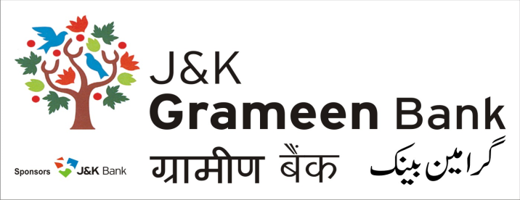
General Administrative Deptt. (GAD)
HEAD OFFICE
NARWAL, JAMMU
Mobile No.: 9797127377
E-mail: pdg.hoj@jkgb.in
Website: www.jkgb.in
-------------------------------------------------------------------------------------------------------------------------------
Corrigendum & Notice for extension of Tender

Tender for rate contract for Supply, Installation, Testing & Commissioning of DG Sets (CPCB II variant) of different ratings for Offices/ Branches of J&K Grameen Bank - Extension

Please refer to the captioned tender floated for the above work by General Administrative Department, J&K Grameen Bank issued vide Ref No: JKGB/GAD/TEND/2020-2259 Dated: 17.10.2020.

In this connection, it is to inform that the tender schedule has been extended as under:
Obtaining Tender Document | Till 19.11.2020
Last date of receipt of Tenders | 19.11.2020 upto 4 PM
Date & Time of opening of Tender | 20.11.2020 at 12 PM

Moreover please read the Technical Specification under (Financial Bid – Page 15) as below:
- 5 KVA, SP (Minimum 10 BHP) instead of Minimum 11 BHP.
- 7.5 KVA, SP (Minimum 10 BHP) instead of Minimum 11 BHP.

Sd/-

HOD,
General Administrative Deptt.
J&K Grameen Bank Dated: 07.11.2020

